Character Design

# Hero Melee

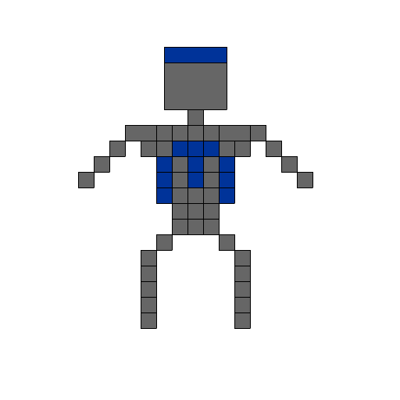

# Hero Ranged

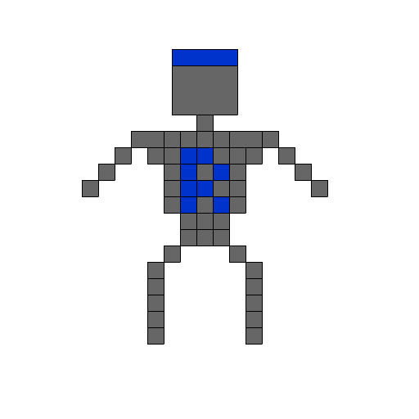

# Enemy Melee

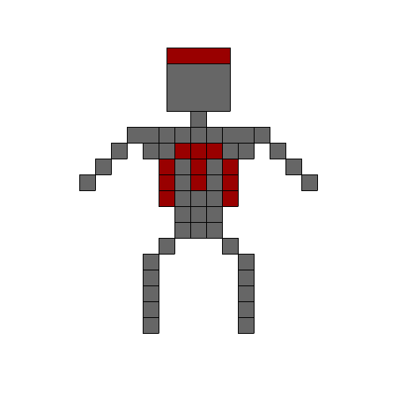

# Enemy Ranged

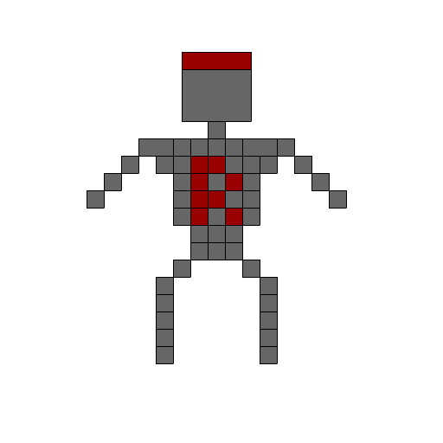

# Unit Attributes

**Characterisation Attributes:**

The attributes that will not be customisable by the player are:

* Max speed – the maximum speed at which the unit can move.
* Max Health – the maximum health a unit can possess.
* Damage – the amount of damage a unit can deal.
* Range – the distance a unit can attack from.

**Status Attributes:**

* Current HP – the current health a unit possesses at that time of the game.